**2024 CSA AGREEMENT FORM**

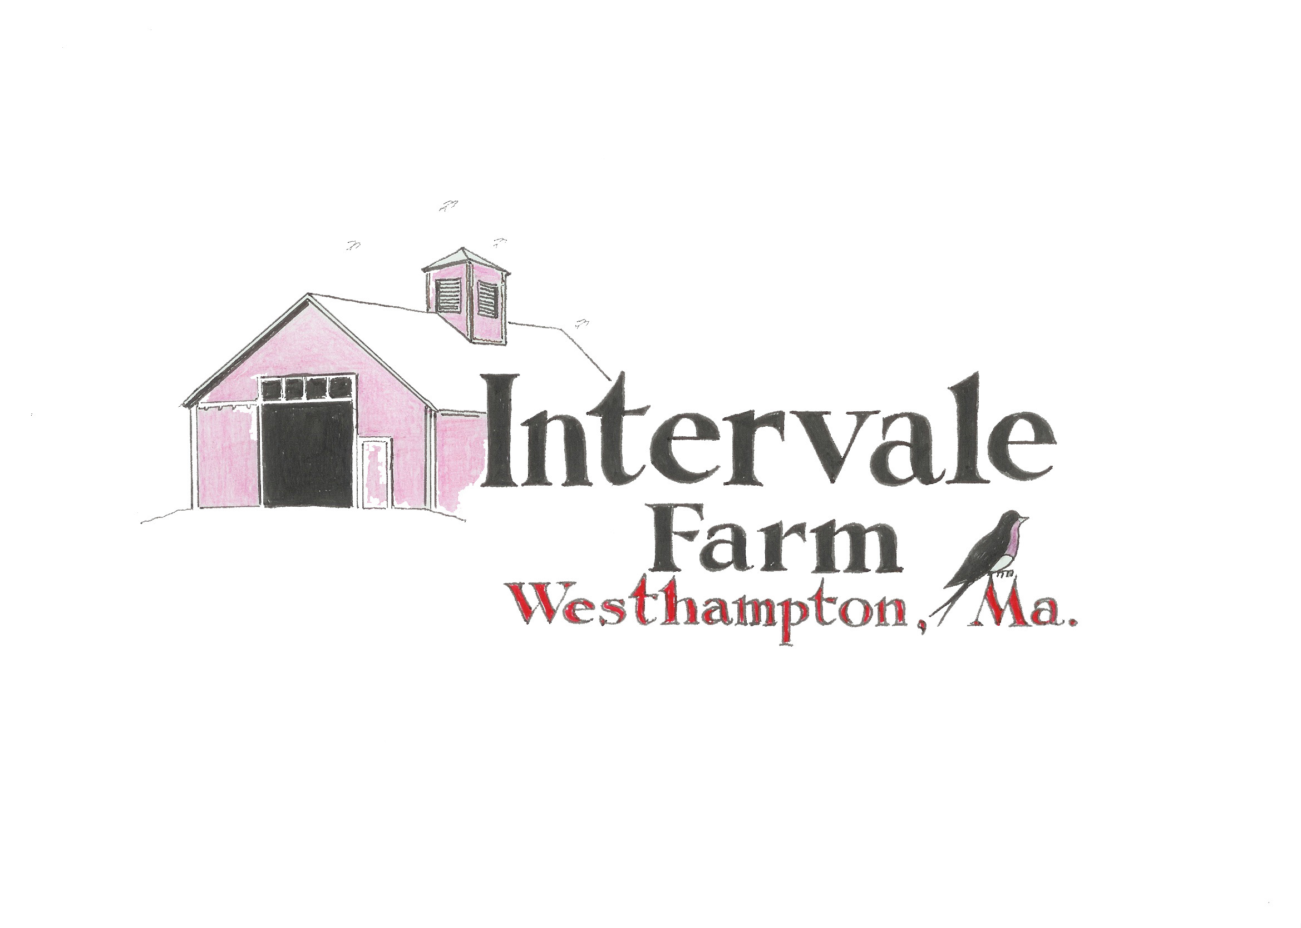

Shareholder

Name

Address

Home Phone e-mail

Membership Commitment

___ Yes. I wish to purchase a share in Intervale Farm CSA. 1 year @ $550

____ I wish to pay in full by March 1, 2024 $ 550

____ I choose the payment plan March 1 $ 175.00

May 1 $175.00

July 1 $200.00

____I choose a medium share 1 year @ $350 in full

___ I choose the payment plan March 1 $175

May 1 $175

____ I prefer Monday pick up 2 to 7 P.M.

____ I prefer Thursday pick up 5 to 7 P.M.

INTERVALE FARM

27 Cemetery Road

Westhampton, Ma 01027

413-527-5440

email - intervale5@comcast.net